UBIC Python Hackathon

Saturday, May 27th

11:00 AM – 2:00 PM

Instructions:

* There are two tracks for this hackathon: beginners and advanced
* You may only use the Python programming language to solve these problems
* Once you have solved a question, please raise your hand and one of the UBIC officers will come and check if your solution
* You may only use stackoverflow.com or official python documentation for online help
* If you win one of the prizes, you will need to explain your algorithm to the rest of the competitors for 3 of the questions
* If you are observed trying to look up the questions or going to any other website, you will be disqualified immediately!

Good Luck!

Questions:

1.

Word-Counting

Input: A string s of length at most 10000 letters

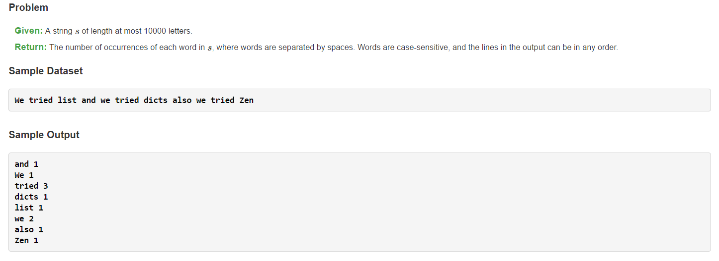Output: The number of occurrences of each word in s, where words are separated by spaces. Words are case-sensitive, and the lines in the output are sorted in alphabetical order

2.

Saul-Goodman

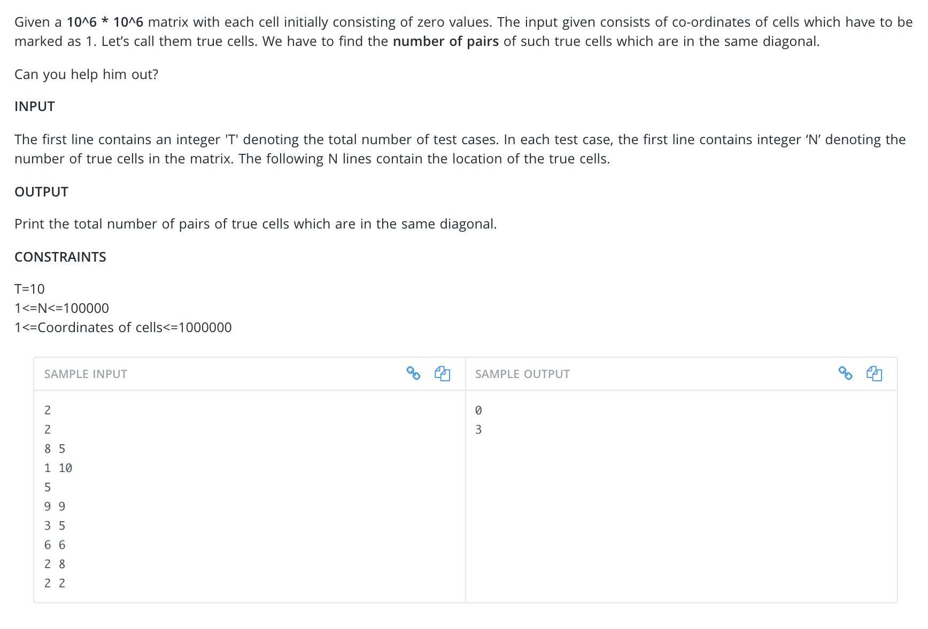

3.

Prime numbers

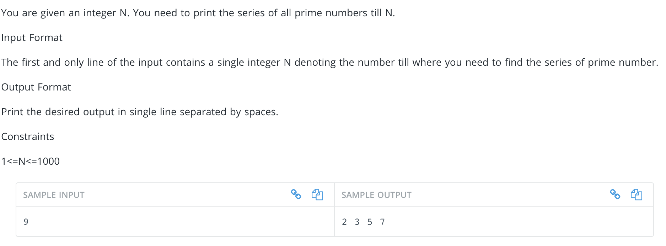

4.

Union-of-Rectangles

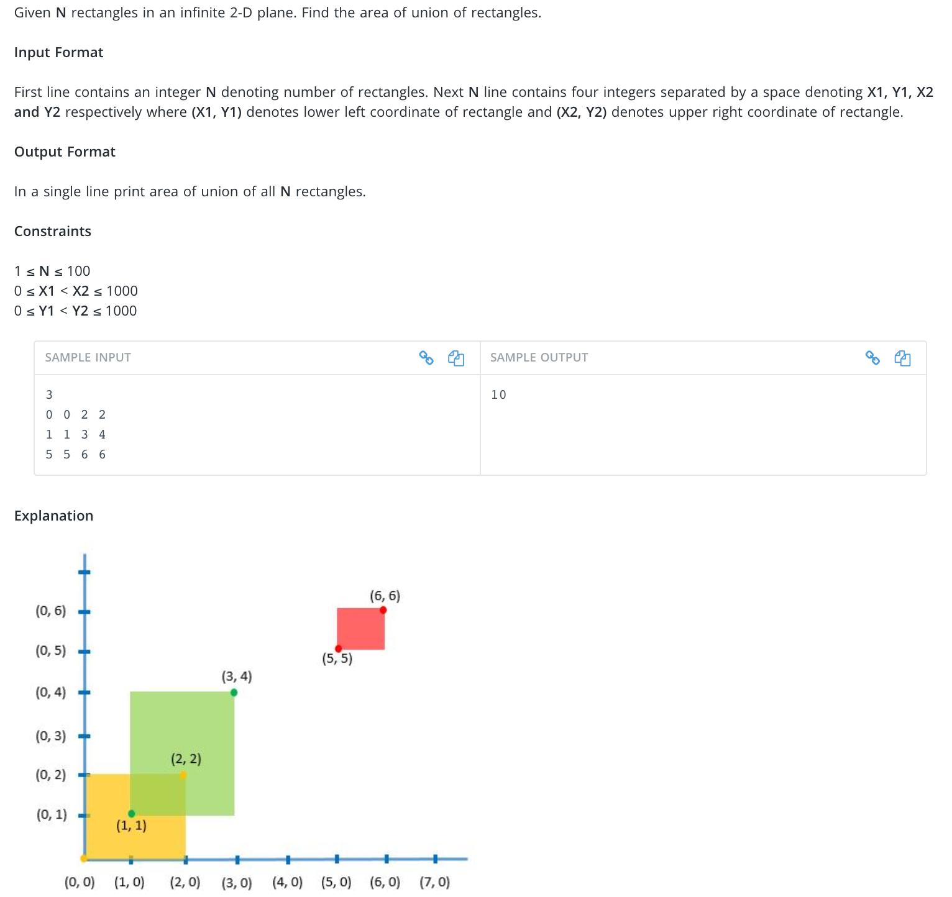

5.

Survival game

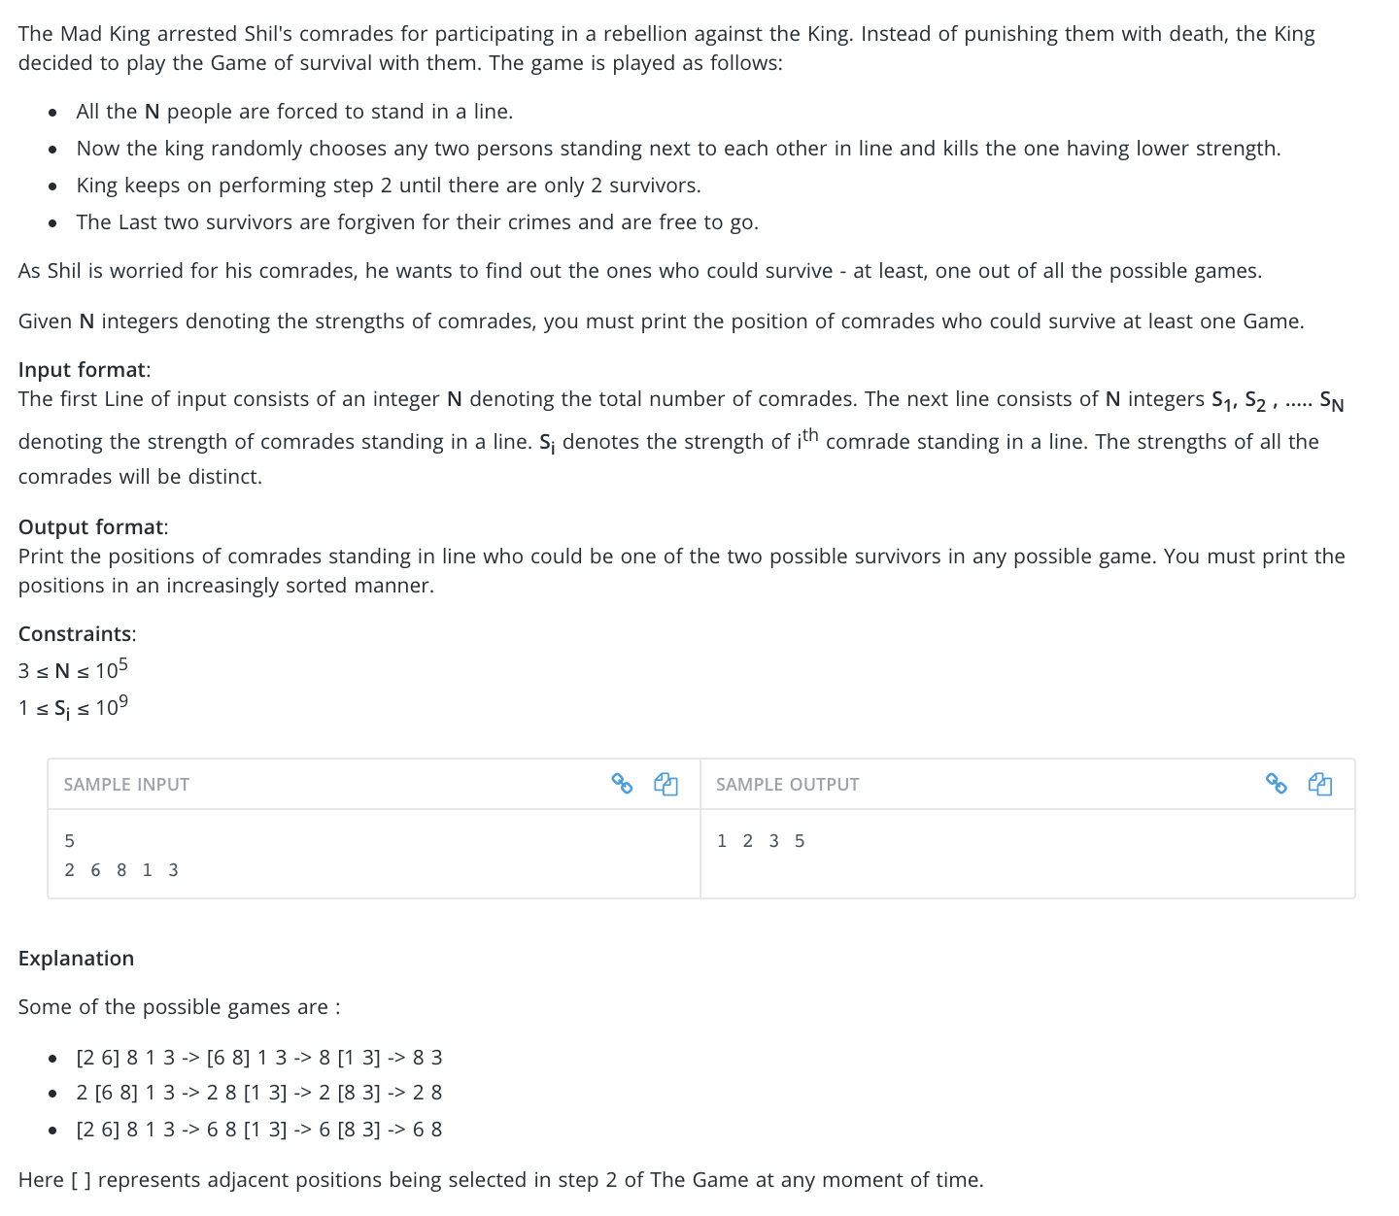

6.

Factorials

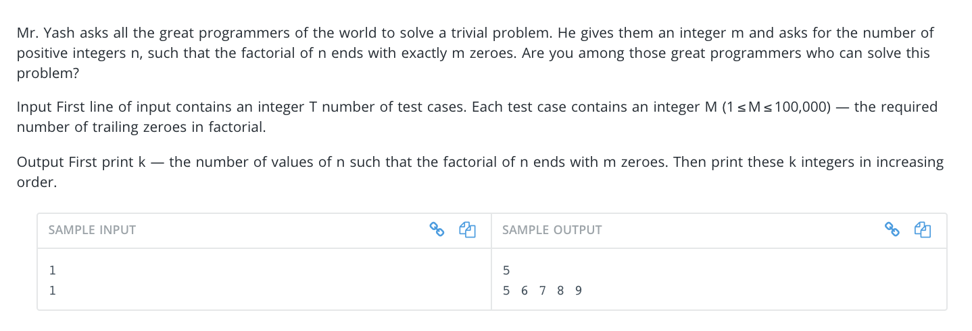

7.

Needle-in-the-Haystack

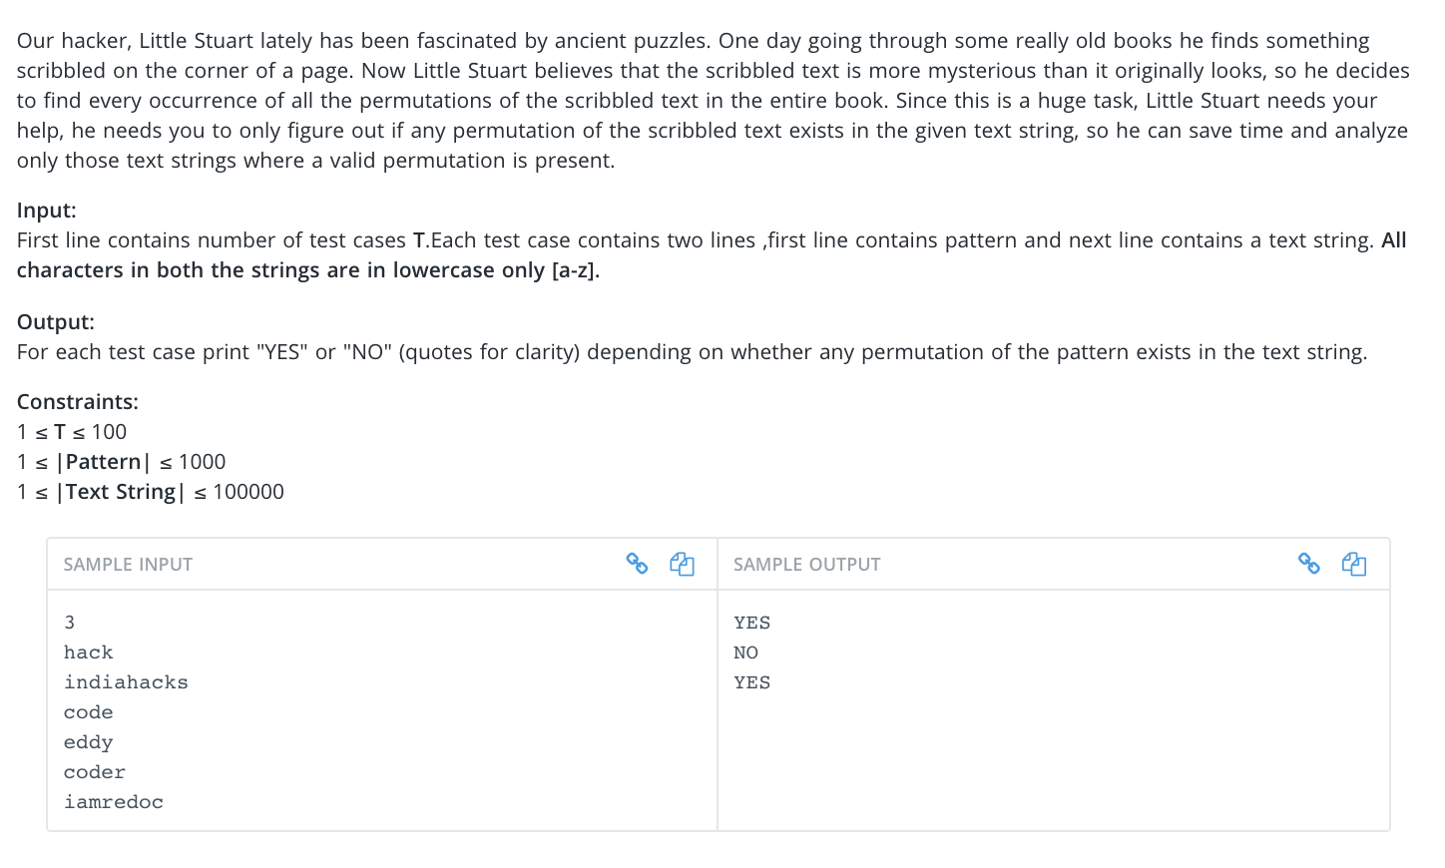

8.

Pokemon

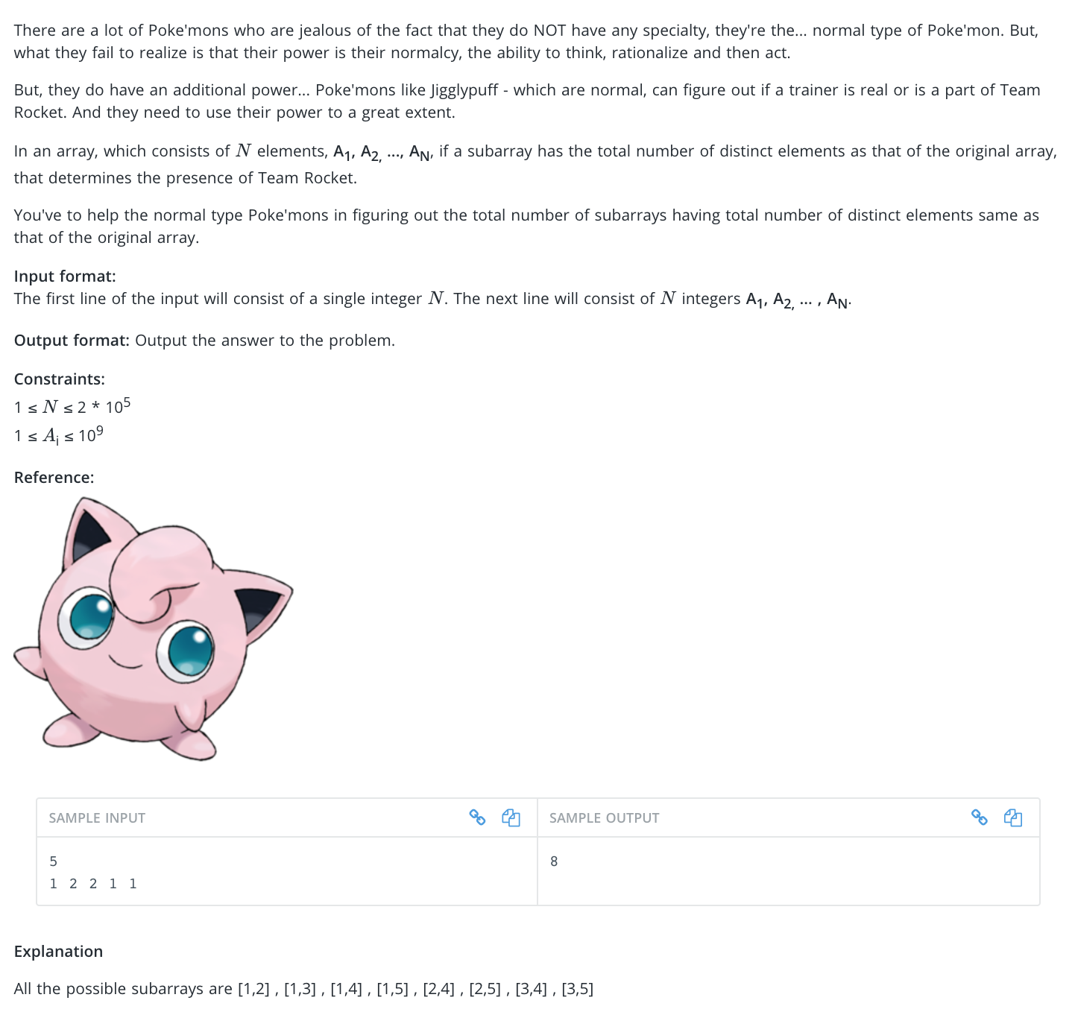

9.

String Queries

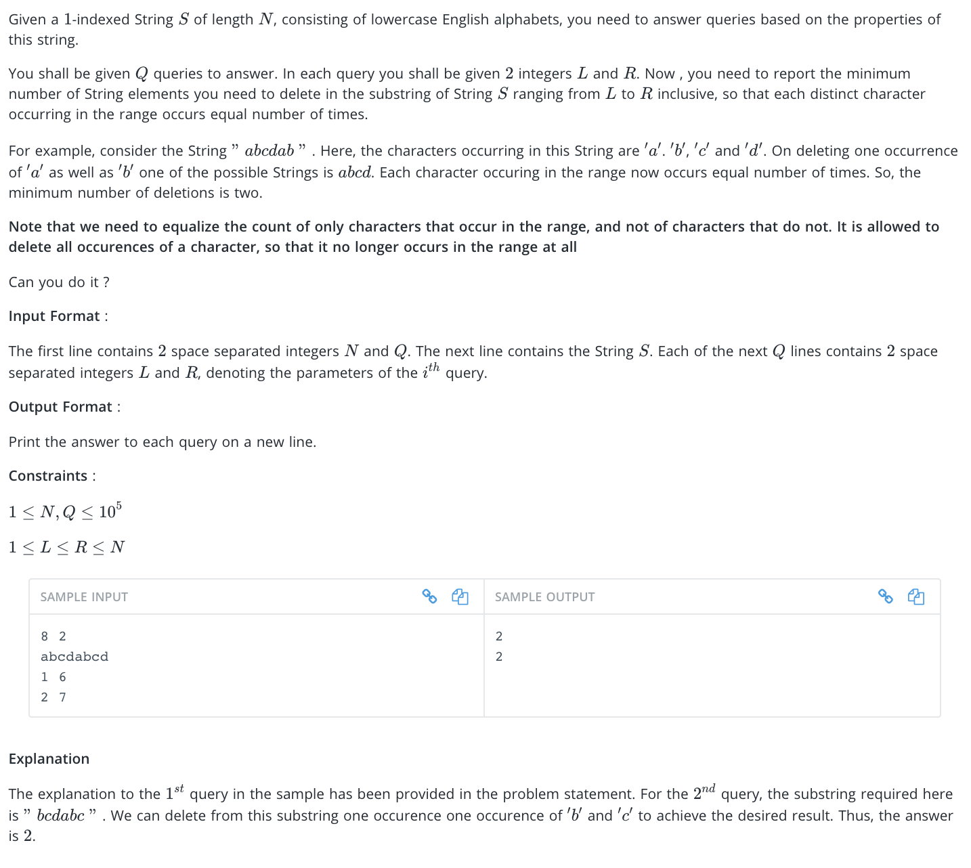

10.

Boolean Expressions

